CTM-I Use Case

Parm Definition Edit

Version 0.1

Use Case Name | Parm Definition Edit
Actor | App Support
Pre-conditions /Assumptions | User has selected to edit a new Parm Definition from the Parm Definition Browse screen.
Post Conditions | User can select to return to the Parm Definition Browse screen by clicking on the “Return to Browse” link.
Screenshot | 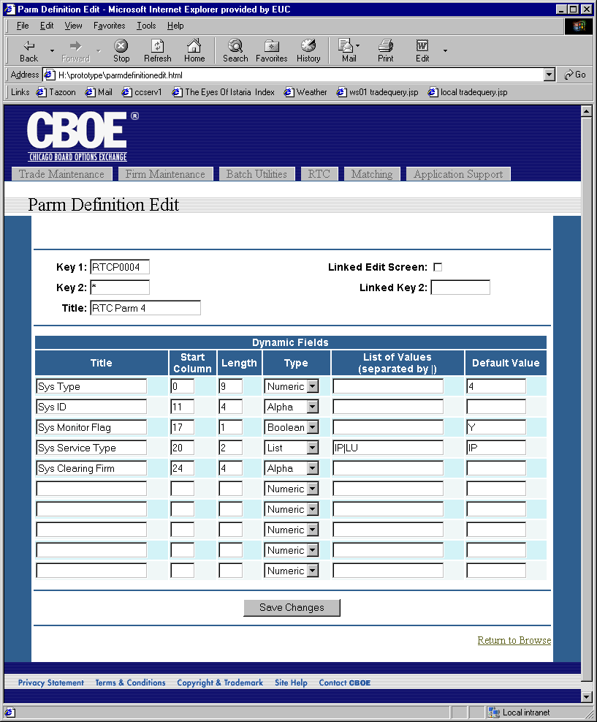
Flow of Events | - The Parm Definition for the specified Parm Definition will be requested from CTM-R.  - Parm Definition Edit screen appears. All fields will be populated from the Parm Definition.  - User can input the following fields  - Key 1 – Allows the entry of a key or a “*” for a wildcard.  - Key 2 – Allows the entry of a key or a “*” for a wildcard.  - Title  - Linked Edit Screen Flag  - Linked Key 2  - A table will allow the user to input the Dynamic Fields. All fields in the table will be editable. 10 rows for 10 fields will show in the table.  - Title  - Start Column  - Length  - Type – Selection of Date, Time, Numeric, Alpha, Boolean, and List.  - List of Values – List of values if the Type is List. Values in the list are separated by a pipe symbol “|”.  - Default Value  - Pressing the “Save Changes” button will request the Parm Definition to be saved.  - Validation will be done to ensure that either Key 1 or Key 2 does not have a wildcard and has a value.  - The Parm Definition will be sent to CTM-R to be saved.  - Results of the CTM-R processing will be displayed on the screen.
Alternative Path

